BIT 4107 – Mobile Application Development
ENHANCED PROFESSIONAL STUDENT LOGBOOK
Student Name: BRIAN MUSEMBI
Admission Number: BIT/2024/33660
School/Faculty: COMPUTING AND INFORMATICS
Programme: INFORMATION TECHNOLOGY
Academic Year: FOURTH
Semester: ONE
Lecturer: MICHEAL NYORO
Phone Number: 0798251816

Contents
BIT 4107 – Mobile Application Development 1
Week 1: Introduction to Mobile Application Development 3
Week 2: Mobile Development Environment 7
Week 3: User Interface Design 9
Week 4: Data Management 14
Week 5: Data Management & Networking 18
Week 6: Networking 21
Week 7: Application Architecture 23
Week 8: Event Handling and User Interaction 27

Week 1: Introduction to Mobile Application Development
Practical Activities Undertaken
Screenshots:
Figure 1: Terminal showing the creation of a new Expo project

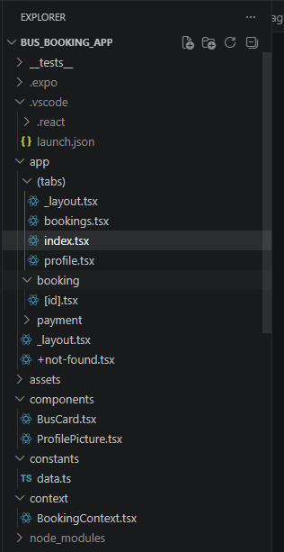
Figure 2: VS Code Explorer showing the Bus_Booking_App folder structure

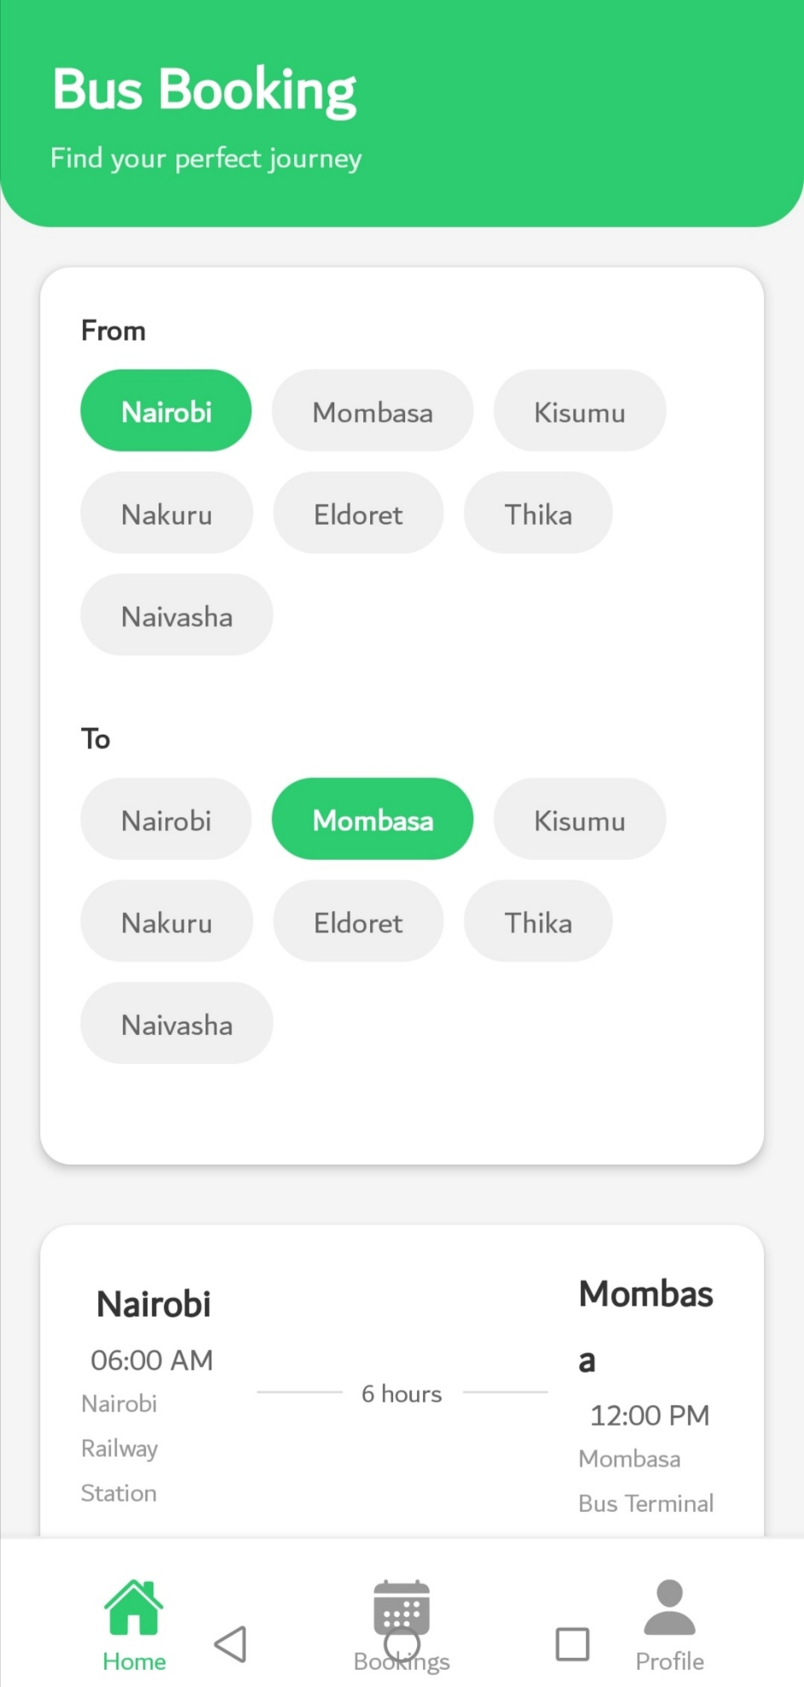
Figure 3: The Bus Booking App running on Expo Go on a physical device

Tools/Software Used
- Node.js - JavaScript runtime for development
- Expo CLI - Framework for building React Native apps
- Visual Studio Code - Code editor with React Native extensions
- Expo Go App - Mobile app for testing on physical devices
- Git - Version control system
- GitHub - Remote repository hosting
Personal Reflection
Setting up the mobile development environment was straightforward with Expo. Understanding the difference between React Native and Expo was crucial. The most valuable lesson was learning how Expo simplifies the development process, eliminating the need for native build tools initially.

Week 2: Mobile Development Environment
Practical Activities Undertaken
Screenshots:
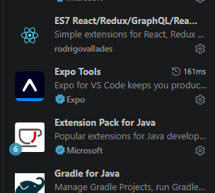
Figure 4: VS Code Extensions tab showing React Native Tools

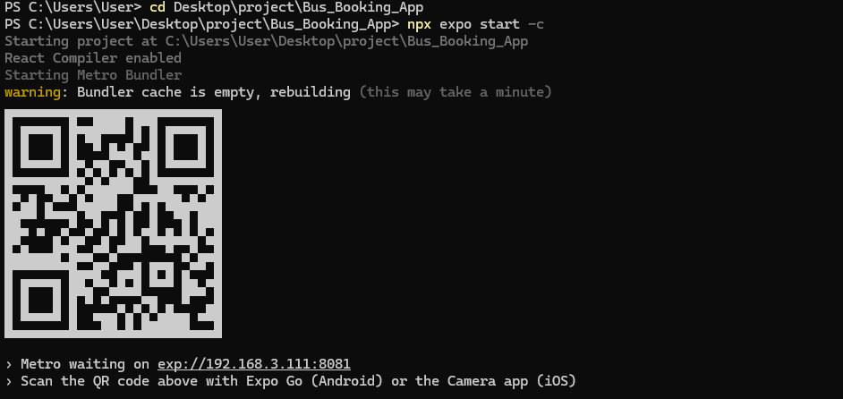
Figure 5: Terminal showing Metro bundler running with QR code

Tools/Software Used
- VS Code Extensions: React Native Tools, ESLint, Prettier
- Expo CLI - Development server and build tools
- Android Studio - Android emulator (optional setup)
- Git & GitHub - Version control and collaboration
- Terminal/PowerShell - Command-line operations
Personal Reflection
Configuring VS Code for optimal React Native development was educational. Learning debugging tools and code formatting improved my workflow. The PowerShell execution policy issue taught me to troubleshoot environment-specific problems. Understanding the development workflow from code to device is now clear.

Week 3: User Interface Design
Practical Activities Undertaken
Screenshots:


Figure 6: Home screen showing bus listings, destination filters, and green header

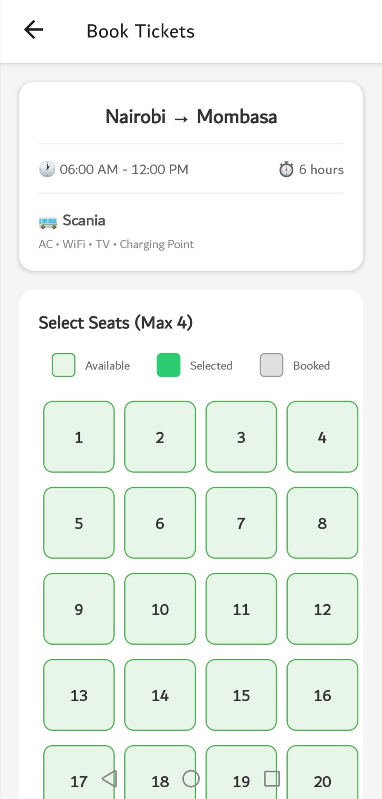
Figure 7: Seat selection screen showing available, selected, and booked seats

Tools/Software Used
- React Native Components: View, Text, TouchableOpacity, ScrollView
- StyleSheet - Styling in React Native
- Flexbox Layout - Responsive UI design
- Expo Vector Icons - Icon library for app icons
- React Navigation - Tab and stack navigation
Personal Reflection
Designing mobile interfaces requires careful consideration of touch targets, spacing, and visual hierarchy. I learned how Flexbox in React Native differs from CSS Flexbox. Creating reusable components like BusCard improved code maintainability and consistency across screens.

Week 4: Data Management
Practical Activities Undertaken
Screenshots:
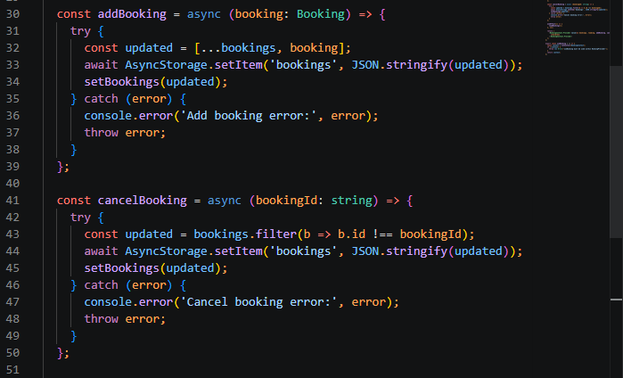
Figure 8: Code showing AsyncStorage save and load functions in BookingContext

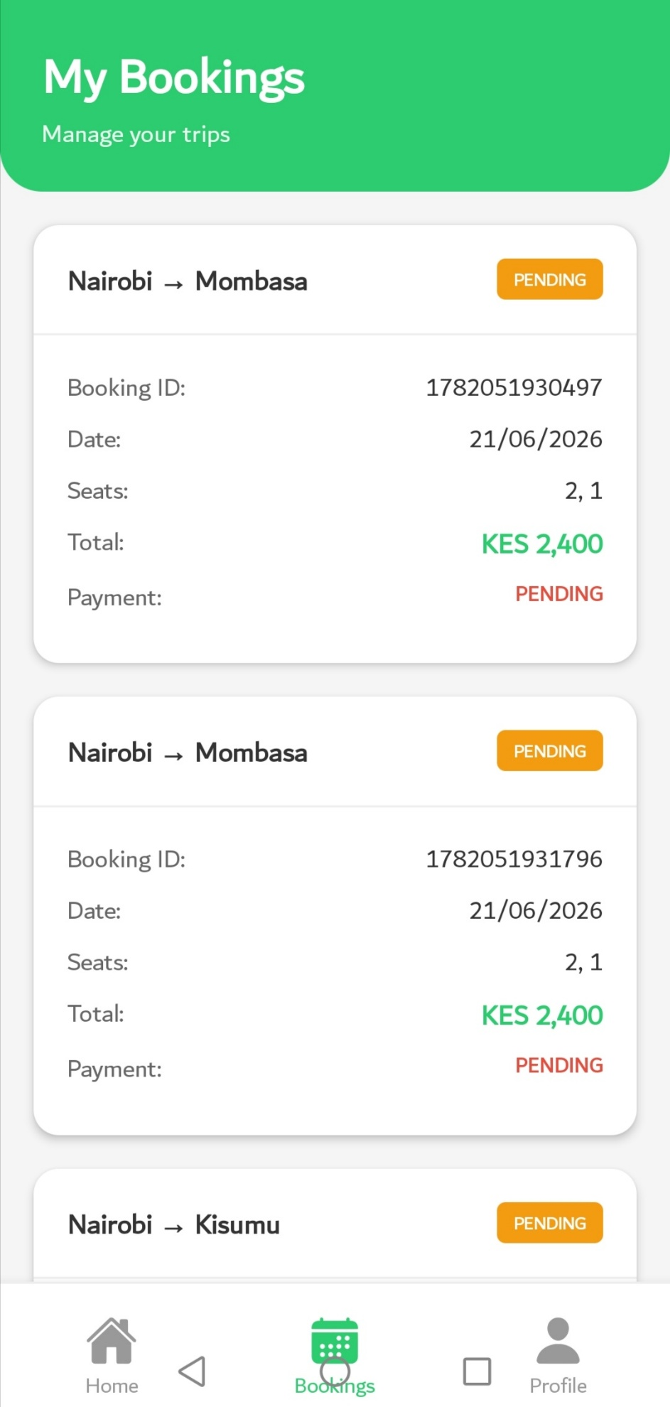
Figure 9: Bookings screen showing saved bookings with status and details

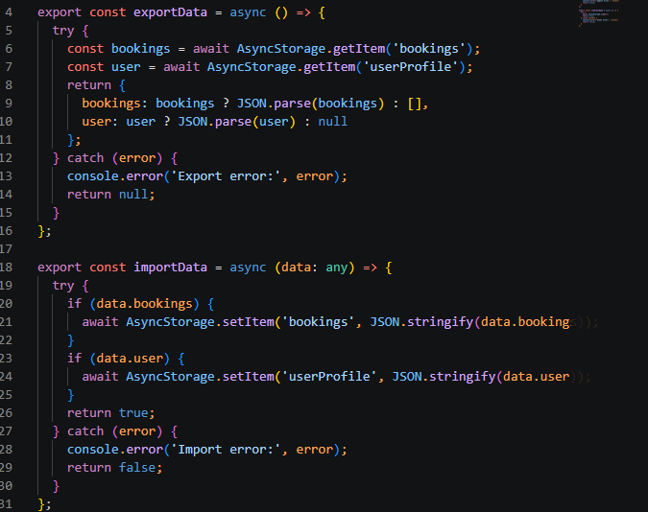
Figure 10: Profile screen showing Export Data and Clear All Data options

Tools/Software Used
- AsyncStorage - Local data persistence
- JSON Serialization - Data storage format
- React Hooks - State management
- TypeScript Interfaces - Type safety for data
- Array Methods - Data manipulation (filter, map, find)
- SecureStore - Secure data storage for sensitive information
Personal Reflection
Data management is critical for mobile apps that need to persist user information. I learned to store, retrieve, and update data using AsyncStorage. Creating the booking system with status tracking and cancellation functionality taught me about data integrity and user state management.

Week 5: Data Management & Networking
Practical Activities Undertaken
Screenshots:
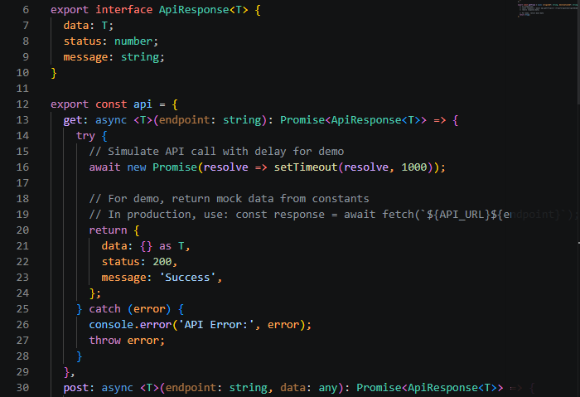
Figure 11: API service with GET and POST methods for network communication

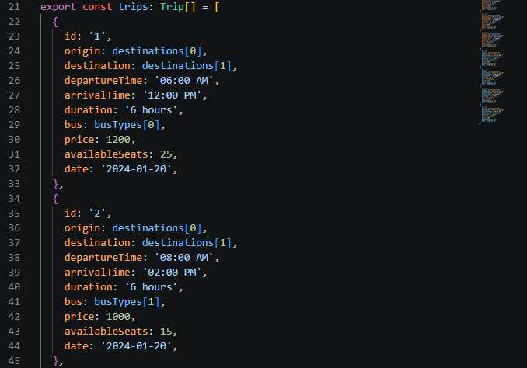
Figure 12: Sample trip data structure in constants

Tools/Software Used
- Fetch API - HTTP requests
- Async/Await - Asynchronous operations
- JSON - Data exchange format
- Mock APIs - Simulated backend data
- Error Handling - Try-catch blocks for network errors
- Loading States - User feedback during network requests

Personal Reflection
Networking is essential for modern apps that require real-time data. I learned how to make HTTP requests using the Fetch API and handle responses asynchronously. Implementing loading states and error handling improved user experience and app reliability.

Week 6: Networking
Practical Activities Undertaken
Screenshots:
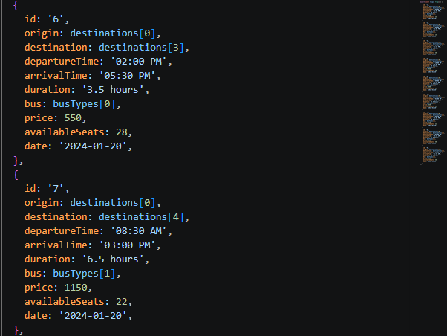
Figure 13: JSON response structure from API calls

Tools/Software Used
- Fetch API - HTTP requests and responses
- Async/Await - Asynchronous operations
- JSON - Data exchange format
- RESTful Web Services - API communication
- Error Handling - User-friendly error messages
- Loading States - Visual feedback during requests
Personal Reflection
Understanding client-server architecture and RESTful APIs was transformative. I learned how mobile applications communicate with servers and exchange data securely. Implementing GET requests and handling responses asynchronously prepared me for real-world API integration scenarios.

Week 7: Application Architecture
Practical Activities Undertaken
Screenshots:
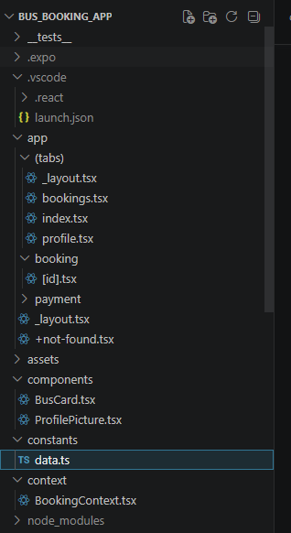
Figure 14: Complete project structure with organized folders

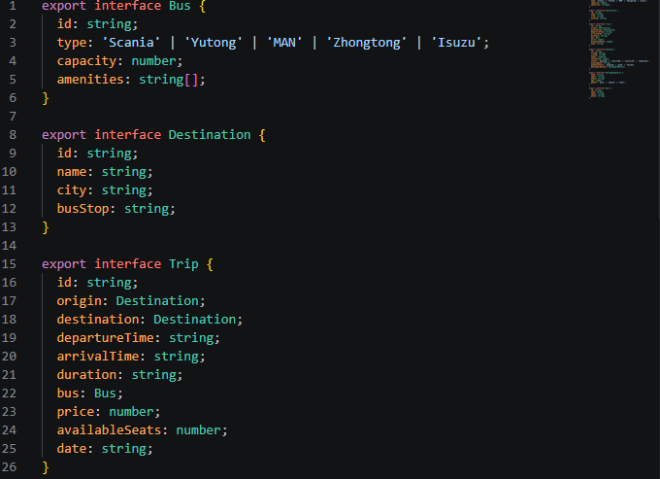
Figure 15: TypeScript interfaces for Bus, Trip, Booking, and User

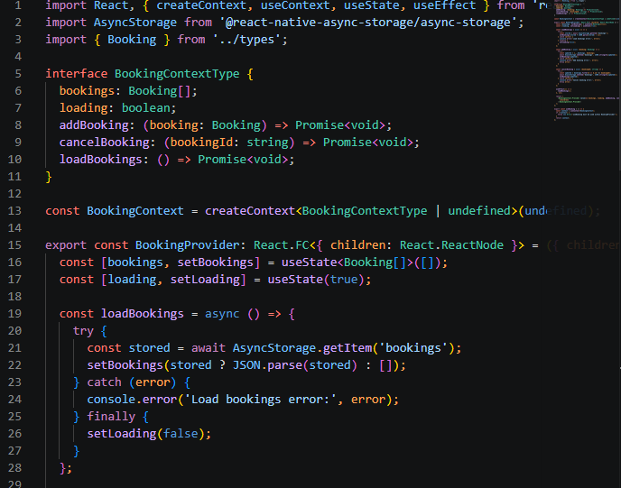
Figure 16: BookingContext provider with state management functions

Tools/Software Used
- Folder Structure - Organized project architecture
- TypeScript - Type safety and interfaces
- Context API - State management
- Component Pattern - Reusable UI components
- Separation of Concerns - Divided code by functionality
- Constants File - Centralized data management

Personal Reflection
Application architecture determines code maintainability and scalability. I learned to organize a React Native project following best practices: separating components, constants, types, and screens. Using TypeScript interfaces ensured type safety across the app. The component-based architecture allowed for code reusability.

Week 8: Event Handling and User Interaction
Practical Activities Undertaken
Screenshots:
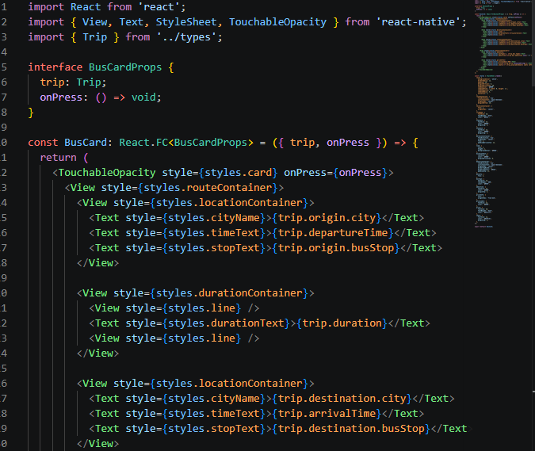
Figure 17: BusCard component with TouchableOpacity press event handler

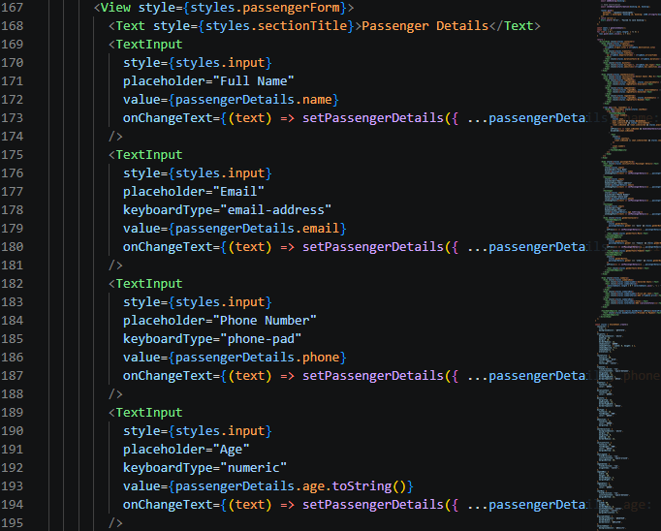
Figure 18: Passenger details form with TextInput onChangeText handlers

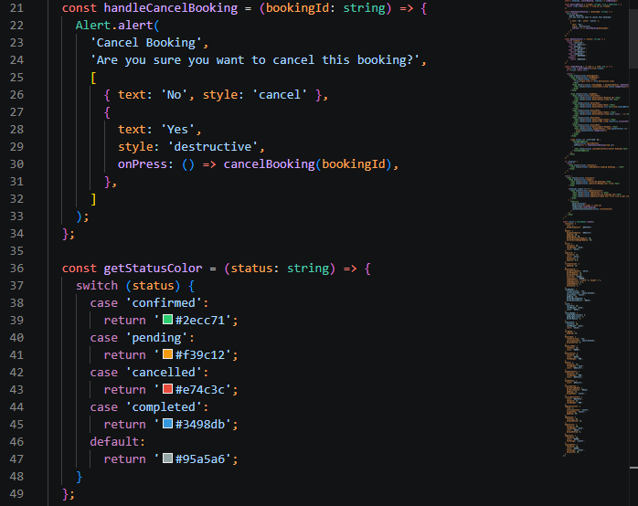
Figure 19: Alert dialog for booking cancellation confirmation

Tools/Software Used
- React Native Components: TouchableOpacity, TextInput, FlatList
- React Hooks - useState, useEffect for state management
- Expo Router - Navigation between screens
- Alert API - User feedback and confirmations
- RefreshControl - Swipe gesture handling
- Input Validation - Form validation logic
- Event Handlers - onPress, onChangeText, onRefresh
Personal Reflection
Event handling is the core of interactive mobile apps. I learned to manage complex interactions like seat selection, form validation, and swipe gestures. Implementing user feedback through alerts and confirmations improved the user experience. The class-based approach to event handling promotes code organization and maintainability.

